

Rapid Reverse
User Guide

Prepared by: Rapid Solutions and Consulting LLC
Last Updated: October 13, 2016

Table of Contents

1. Introduction 3
2. Getting Started 4
3. Running REVERSE 8
4. Options Panel 16
5. Filtering by Oracle Users Panel 17
6. Filtering by Date Panel 18
7. Template Selection 19
8. Known Issues 20

1. Introduction
Reverse extracts configurations from an Oracle instance in xml format. Those xml files are then uploaded to Configurator in order to generate a BR100. The BR100 format is an ORACLE AIM METHOD step where the detail of each screen to be used in configuring the oracle system is documented in a table format, each column in the table represents a field on the screen and the value in each column represents the data that would be entered into that field.

The extracted configuration data is placed into xml files in the BR100 format for each screen that was extracted. The choice of using xml is primarily due to the ability of Configurator to load configuration data into the KNOWLEDGE BASE directly from xml sheets.

With this method the Reverse process is able to run on the source ORACLE instance in a SECURE environment. The resulting xml sheets can then be uploaded to the KNOWLEDGE BASE as a separate step and no direct connection is needed between the KNOWLEDGEBASE and the ORACLE INSTANCE.

2. Getting Started
- Export the “Inventories Package” file needed for Reverse as per the scenario that you wish to extract configurations for. Below are the steps on how to export the inventories package from a scenario:

- Log on to RapidConfigurator
- Select “Scenarios”

- Depending on the business case that you wish to accomplish, ie whether to extract all the configurations for an existing operating unit or a specific module like Project Accounting, then you will need to select the right scenario.
- Right click on your chosen scenario:

- Select the “Export Inventories for Reverse”
Note:
ERP scenarios: This scenario will extract all configurations which includes Instance level and Operating Unit level configurations.

Tips: Note that you can also export inventories at the responsibility, menu, form and table level
by right-clicking the appropriate node in the “Browse Repository” tree structure.

- Once the export process is completed, Configurator will show the status and will generate a link to download the package. Select “Click here to download the archive”

- Save the file into your local folder.

Note that you may encounter warnings if your project doesn't have some SQL loaded into it. This can occur when a few specific tables will lack SQL. Those tables will not be able to be reversed.

If you are provided with SQL from Rapid e-Suite separate from your project/KB file, you can load it via the 'Script Management' page linked to off of the main menu, via the link at the bottom that says Import Reverse SQL:

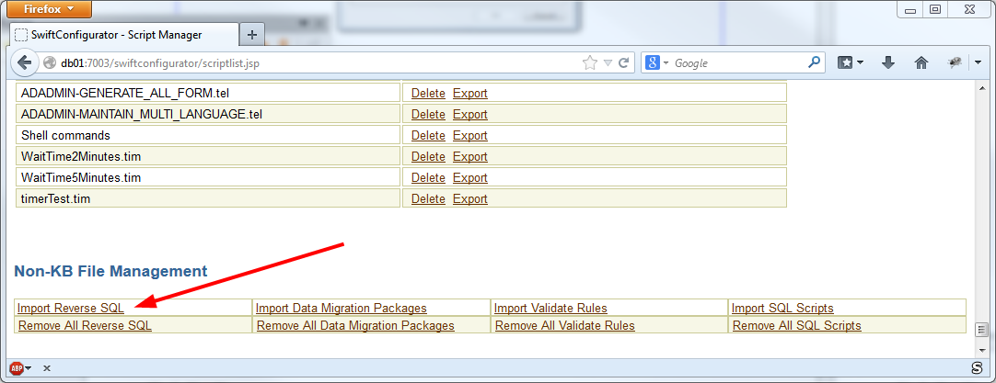

3. Running REVERSE
1) Double-click the desktop icon, and a screen like the following should appear:
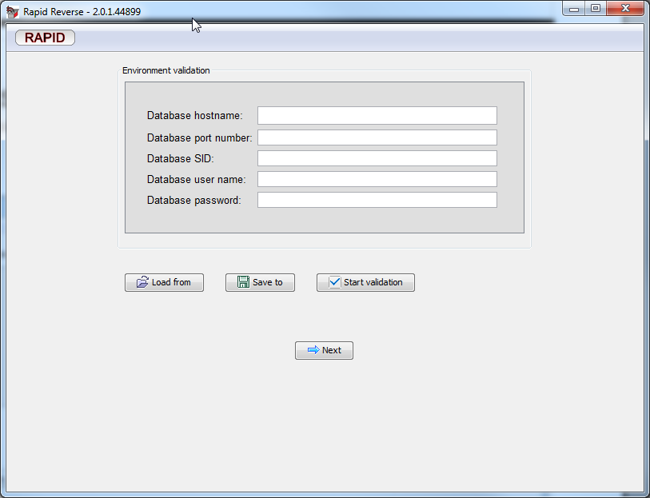

- Fill in the environment properties or load them from a file, you can use the template provided in the installation folder for that purpose:

environmentTemplate.rapidreverse

Environment parameters:

Here is a complete reference of each parameter and what needs to be keyed in:
Please replace the highlighted values in RED with you oracle EBS server information.
Consult with your Oracle Database Administrator for any parameters that you are unfamiliar with.

- Database hostname = oratest16.rapidesuite.com
It contains the hostname to access the EBS Database server.
- Database SID = ERPP
It contains the specific Oracle database identifier called SID.
- Database port number = 1521
It contains the port number of the Oracle Database listener.

- Database user name = APPS
It contains the login necessary for a database connection to be established from the PC client, note that a user name with the same privileges as APPS is required.
- Database password = APPS
It contains the password necessary for a database connection to be established from the PC client.

Press the “Start Validation” button. If you wish, instead of selecting the environment file every time that you start Reverse, you can set the location of a default environment file in the configuration file engine.properties:

#REVERSE_ENVIRONMENT_FILE=./my_template.bwe

Make sure to remove the sharp sign (#) at the beginning if you want to use this feature and specify the absolute location of the file.

(NOTE: You need to ensure the database connection is established before you can proceed to the next step)

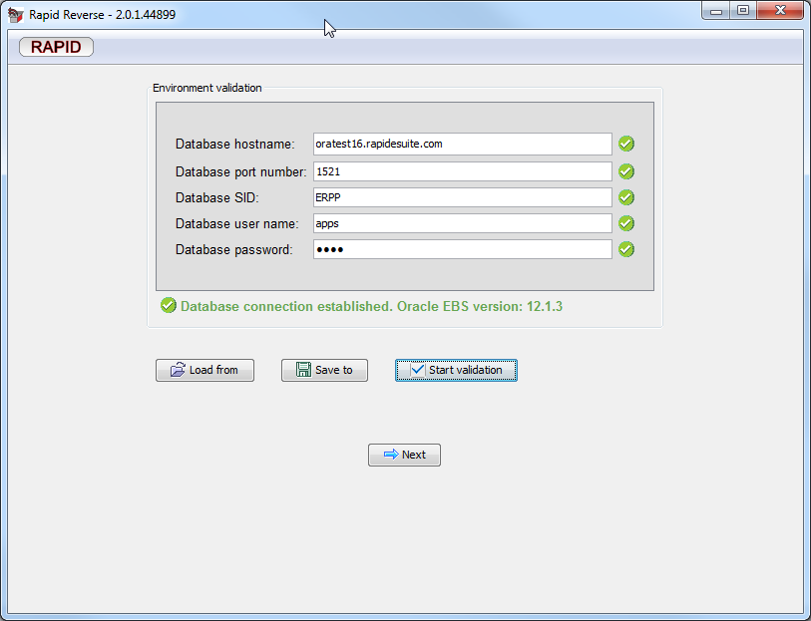
- Press Next.

- The next step is to select the Inventories package file (please refer to another user guide on how to export the inventories package from RapidConfigurator).

Note: a default inventories package file can be specified in the “engine.properties” file by the property: REVERSE_INVENTORIES_PACKAGE_LOCATION

- RapidReverse will automatically install the PL/SQL package necessary to run the server side functions used by RapidReverse when extracting data. Note that you may get a warning if installing an older version to an existing EBS instance.

The next step is to select the Operating Unit names that you wish to extract configurations for.
Note that you can also select the type of configurations by using:
    - Operating Unit specific setups: RapidReverse will only extract configurations specific to the Operating Unit selected.
    - Instance Level setups: RapidReverse will only extract configurations which are at the instance level (shared across all operatings units).
The default settings is to extract both settings and it is recommended to not change it unless you have been advised by your Rapid Consultant.

Note: Selecting more than one operating unit will dramatically increase the run time – please consider launching another copy of REVERSE for another operating unit.
Selecting the instance level configurations and an operating unit may dramatically increase the run time depending on your EBS Database – please consider launching another copy of REVERSE for the instance level request.
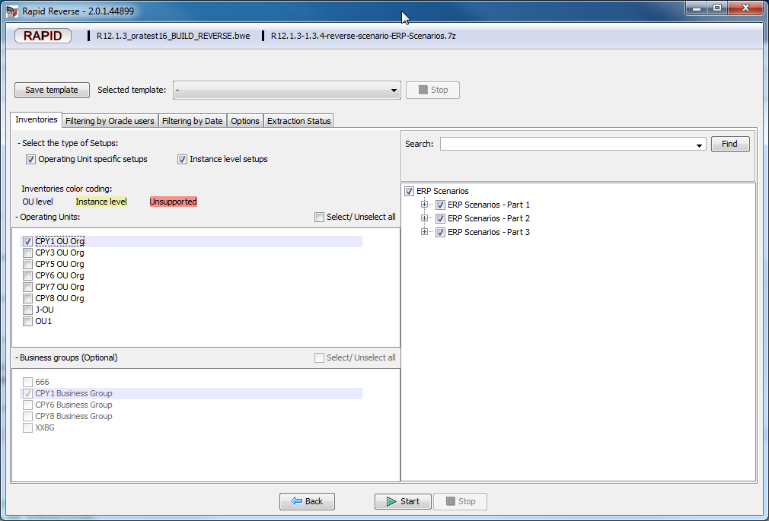

- Click [button] Start.

- The extraction progress will be shown on the “Extraction Status” panel:

When REVERSE has completed all the tasks a summary will be displayed:

All the extracted information is stored in a ZIP file located in a folder called ZIP-FILES in the installation directory of REVERSE.
Note that you can change that default settings in the “Options” panel:

4. Options Panel

Run in Analysis mode:
- Checked:
  - REVERSE will not extract the configurations, but provide the analysis record count for each table, this is useful to determinate which tables that will take a long time to extract due to large volume.
- Unchecked:
  - REVERSE will perform the actual configurations extraction into xml files.

Enable Audit Extraction:
- Checked:
  - The audit information for every record will be extracted as well. The audit information consists of the “Last update date” and “Last updated by” Oracle database columns.
- Unchecked:
  - No audit information extracted.

Select the folder where the ZIP file will be stored:
- Specify the folder where the ZIP files containing the extracted data files, will be created. Note that the default zipped file location is specified in the engine.properties file: REVERSE_ZIP_FILE_LOCATION.

Number of workers:
- You can overwrite the default number of workers to speed up the execution of queries in parallel. The default value is specified in the engine.properties file: REVERSE_WORKERS_COUNT.

5. Filtering by Oracle Users Panel

This panel allows you to filter the configurations by Oracle user name. It will extract the configurations based on a list of Oracle user names, both types of seeded users and standards users can be included or excluded.

NOTE: it is recommended to NOT change the default settings which are to exclude only oracle seeded users and automatically include all the rest of the oracle users. Not doing so may result in performance issues or worse missing configurations.

NOTE: the Oracle user names are translated into Oracle Ids then passed to the WHERE condition of the SQL queries so selecting hundreds of users manually will cause the WHERE condition to include hundreds of Ids which will degrade the performance of the queries by hours more when it should only take seconds. Therefore it is not advised to select many checkboxes on this panel.

In the case where your Oracle DB contains standard users created by seeded Oracle users (example using SQL Loader and -1 as the created_by) then REVERSE will notify you (potential seeded users) with a warning. Normally, no specific action is needed.

6. Filtering by Date Panel

This panel allows you to filter the configurations by the Oracle LAST_UPDATE_DATE or CREATION_DATE columns.
It will extract the configurations based on a list on a range of dates: From – To. The Time component can also be selected.
By default REVERSE is selecting from 01-jan-2005 as to ignore seeded oracle configurations.

7. Template Selection
You can save all the options that you selected (check boxes, selected tree branches, operating unit names,…) into a “template”. This is very helpful if you do not want to reselect all the options, inventories,… the next time that you start Reverse.

8. Known Issues

- It is possible the SQL statements may in some cases not execute – this is primarily due to Oracle application patch levels creating differences. The workaround for that issue is to uncheck the appropriate file in the Reverse screen and extract the data manually.

- Knowledge Base structure differences may cause data to fail when loading into Configurator.

End of File

